Technical Documentation for Development of 3D Tetris Shuffle

Codebase

The codebase for our project is all located within the folder of ‘scripts’, which is the default folder that Unity grabs C# files from. Scripts are attached to objects that they control or interact with, and many variables from them are available to be added/modified from the object inspector (*Fig 1.*).

These variables are set to public in the corresponding script, which allows them to be modified before runtime outside of the scripts (*Fig 2*).

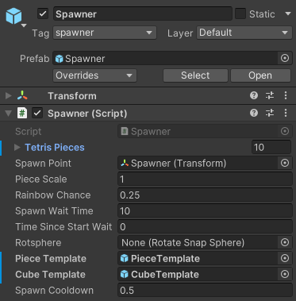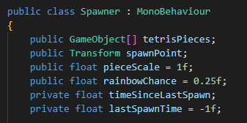*Figures 1 & 2, Public variables visible within object inspector*

We have a standardized layout for all of our scripts, with public class objects defined at the top of the files, and unity standard start/update functions located below, along with any helper functions.

The main aspect of our game that is the core for gameplay is the piece generation function, which generates piece objects on the fly. The only thing the developer would need to know is where to generate each ‘block’ contained in the piece in 3D space before instantiating the object as a whole (*Fig 3*).

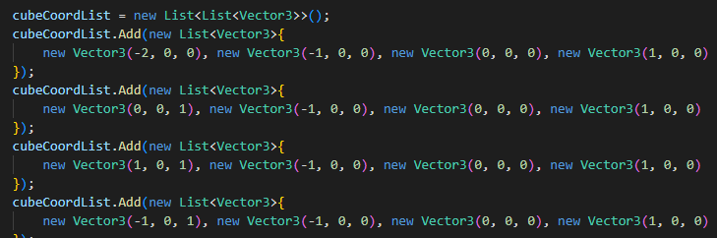

*Figure 3, Piece creation method for 4 different Tetris blocks*

Implementation

The nice part of having our development separated from desktop and virtual implementations is that we are able to test our functionality in the desktop environment before porting it into the virtual reality environment. The two scenes CurrentVersion and XRinCurrentModel both implement the gameplay scene in the desktop and virtual environment respectively (*Fig 4 & 5*).

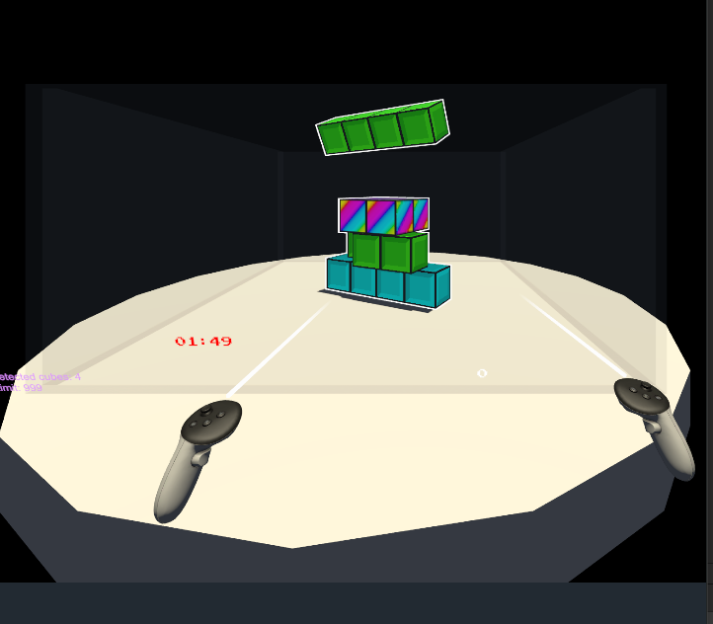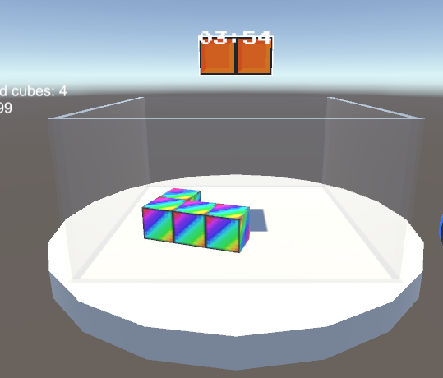

*Figures 4 & 5, Virtual and Desktop version of game*

Further documentation on our project can be found in the [Readme.MD](https://github.com/mts-cocopuff/CS.002-3D-Tetris/blob/main/README.md) file in our github repository.